**Nginx 反向代理并缓存及缓存清除**

原文地址：http://www.cnblogs.com/caoguo/p/5012447.html

**一. Nginx 配置**

[复制代码](javascript:void(0);)

#user nobody;

worker_processes 1;

#error_log logs/error.log;

#error_log logs/error.log notice;

#error_log logs/error.log info;

#pid logs/nginx.pid;

events {

worker_connections 1024;

}

http {

log_format main '$remote_addr - $remote_user [$time_local] "$request" '

'$status $body_bytes_sent "$http_referer" '

'"$http_user_agent" "$http_x_forwarded_for"'

'$upstream_addr $upstream_status $request_time $upstream_response_time';

access_log /var/log/nginx/access.log main;

error_log /var/log/nginx/error.log;

server_tokens off;

include mime.types;

default_type application/octet-stream;

sendfile on;

tcp_nopush on;

client_max_body_size 10m;

client_body_buffer_size 128k;

proxy_connect_timeout 300;

proxy_send_timeout 300;

proxy_read_timeout 300;

proxy_buffer_size 64k;

proxy_buffers 4 512k;

proxy_busy_buffers_size 512k;

proxy_temp_file_write_size 512k;

proxy_temp_path /data/nginx/proxy_temp;

proxy_cache_path /data/nginx/proxy_cache levels=1:2 keys_zone=cache_one:2000m inactive=3d max_size=500g;

proxy_redirect off;

proxy_set_header Host $host;

proxy_set_header X-Real-IP $remote_addr;

proxy_set_header X-Forwarded-For $proxy_add_x_forwarded_for;

gzip on;

gzip_min_length 1k;

gzip_buffers 4 16k;

gzip_http_version 1.1;

gzip_comp_level 2;

gzip_types text/plain application/x-javascript text/css application/xml;

gzip_vary on;

upstream go {

server www.cnblogs.com:80 weight=4;

#server 42.121.252.58:80 weight=4;

}

server {

listen 192.168.55.133:80;

#server_name www.cnblogs.com;

access_log /var/log/nginx/go.access.log main;

error_log /var/log/nginx/go.error.log error;

location / {

proxy_cache cache_one;

#proxy_cache_valid 200 304 301 302 2h;

#proxy_cache_valid any 2h;

#expires 1d;

add_header X-Cache $upstream_cache_status;

proxy_pass http://go;

proxy_cache_key $uri$is_args$args;

}

location ~ /purge(/.*) {

allow 127.0.0.1;

allow 192.168.55.0/24;

deny all;

proxy_cache_purge cache_one $1$is_args$args;

}

}

}

[复制代码](javascript:void(0);)

**二. 测试**

1.首次访问

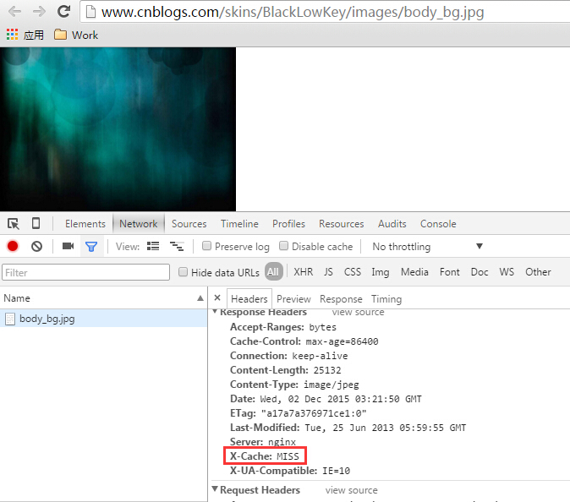

2.刷新一次，也就是第二次访问

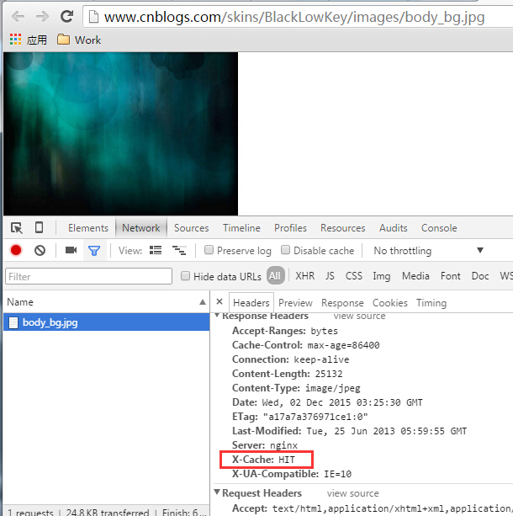

3.缓存清理

